**Module–1(Fundamental)**

1) What is SDLC

a) SDLC is a structure imposed on the development of a software.it has six phase

1] Requirement gathering

2] Analysis

3] Design

4] Implementation

5] Testing

6] Maintenance

2) What is software testing?

a) software testing is a process of completeness, correctness, quality.

3) What is agile methodology?

a) Agile SDLC model is a combination of iterative and incremental process models which focus on process adaptability and customer satisfaction with rapid development software.

4) What is SRS

a) SRS is a complete document of how the software will work.

5) What is oops

a) Object oriented programming system. It Identify the object and assign their value. object can communicate with other objects by sending the message through method.

6) Write Basic Concepts of oops

a) class, Encapsulation, Polymorphism, Abstraction, Overloading, Inheritance

* class is the blue print of the object for example when you think to build a car first the blue print is create
* Encapsulation is use to hide the important data from other object. Other object can not this data. For example when you type your pin in ATM it hide the pin.
* >Polymorphism means different objects can respond to the same message in different ways. for example in class in my class I have same name friend.
* Abstraction it hide the important date and display the rest of the data.

Overloading exiting operator is made to operate on new data type. There are two type of Overloading

1 method Overloading

2 operator Overloading

* Inheritance means to inherit the characteristics of another class. For example you inherit the property from your father your father inherit that property from their father.

7) What is object

a) object is the combination of attribute and method. For example man is the object.

8) What is class

a) Class is the blueprint of the object. Class can abstract the property of the object. For example car is the class and man who drive the car is the object.

9) What is encapsulation

a)It is use to hide the important data from other object. Other object can not access this data. For example when you type your pin in ATM it hide the pin.

10) What is inheritance

a) inheritance means to inherit the characteristics of another class. For example you inherit the property from your father your father inherit that property from their father.

11) What is polymorphism

a) It means different objects can respond to the same message in different ways. for example in class in my class I have same name friend.

12) Draw Use case on online bill payment system (Paytm)

13) Draw Use case on banking system for customers.

14) Draw Use case on Broadcasting System.

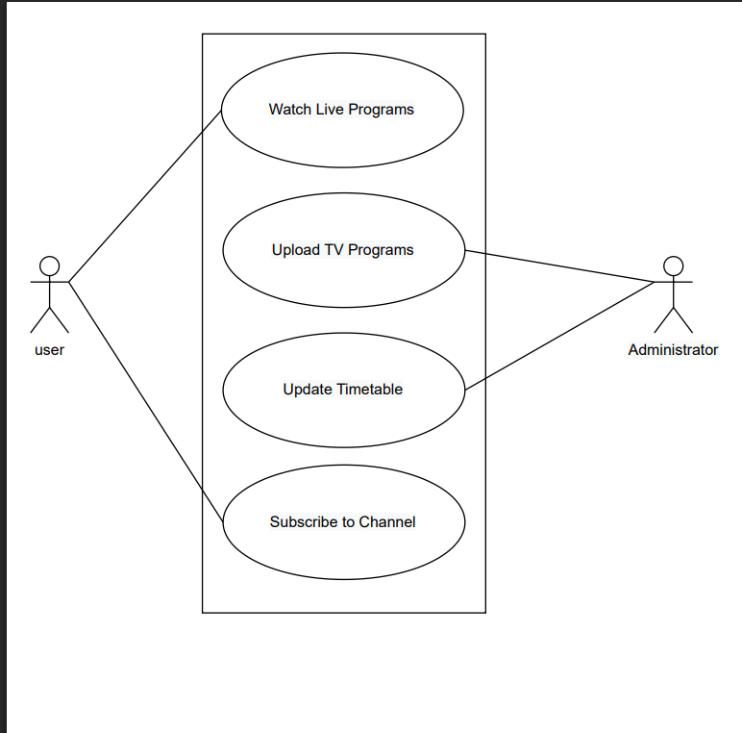

15) Write SDLC phases with basic introduction

a) SDLC is a structure imposed on the development of a software product.it has six phases

1 requirement gathering

2 Analysis

3 Designing

4 Implementation

5 Testing

6 Maintenance

16) Explain Phases of the waterfall model

a) There are six phases of waterfall model

1 Requirements Gathering

* It Means the document and diagram with understanding language
* It has three type of problem Lack of clarity, Requirements confusion, Requirements Amalgamation.

2 Analysis Phase

* It Define “What ”&”How” means what requirement need and how to full fill the requirements.

3 Design Phase

* Design the document which will use to create Product.

4 Implementation Phase

* Gather information from Analysis phase & Designing phase and create the complete product. How ever there is room for some changes if required.

5 Testing Phase

* After & Before the product complete the test team perfume many different test cases on the product to ensure the product quality.

6 Maintenance Phase

* After all the phases the Maintenance Phase comes and its work is to check for defects if any and add new things to product to enhance the quality of product.
* There are three types of defect comes under maintenance Corrective maintenance, Adaptive maintenance, Perfective Maintenance.

17) Write phases of spiral model

a) There are 4 phases of spiral model

* Planning it determines the object
* Risk analysis it check the object for the risk
* Engineering develop the next level product
* Customer evaluation it check the result of the engineering phase

18) Write agile manifesto principles

a) Agile is combination of iterative and incremental process models which ensure the customer satisfaction.it divide the Product into smaller part. In each part the team work on different things like planning, requirements analysis, design, coding, unit testing. After this the final product will create with minimal risk and defects.

19) Explain working methodology of agile model and also write pros and cons

a) Agile believes that every project needs to be handled with different and existing which complete the project requirements.

* Pros
  + planned context
  + little planning is required to manage the Product
  + developer are flexible
  + it is good model for changing requirements and it gave the product early
* Cons
  + Depends on customer if customer gave requirements unclear it affect the Product
  + If new member join the team it may find it difficult because of the less document
  + More risk of maintainability, sustainability, extensibility

20) Draw use case on OTT Platform

21) Draw use case on E-commerce application

22) Draw use case on Online shopping product using payment gateway

